ENGLISH | Chambers Plan Social Content – November 2025
ENGLISH | Theme – Winter wellness and travel

POST DATE | ENGLISH CAPTION | ENGLISH IMAGE PREVIEW
2025-11-04 | Preparing for Black Friday can be chaotic. Get the skills to lead your team with confidence. All Chambers Plan options give business owners access to Arcora’s one-on-one leadership coaching to help you build critical people management and productivity skills.  Talk to your local Chambers Plan advisor to learn more.  #ChambersPlan #ChamberPlan #SmallBusiness #entrepreneur #growth #ProfessionalCoaching #ProfessionalDevelopment | 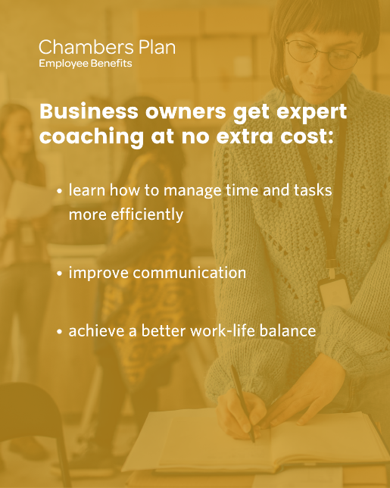
2025-11-06 | Planning your perfect holiday ski trip? Protect your travel investment by adding Trip Cancellation coverage. It even covers lost luggage! Log into my-benefits and click on Switch to Personal Benefits to get started.  #ChambersPlan #ChamberPlan #SmallBusiness #benefits #Travel
2025-11-10 | Our office will be closed tomorrow in honour of Remembrance Day.
2025-11-11 | Today we’re taking time to honour members of the Armed Forces. We want to say "thank you" to those who serve and have served, and remember those who made the ultimate sacrifice.
2025-11-13 | Feeling the exhaustion, sadness and "winter blues" that comes with less daylight and more time inside? It could be more than a simple slump in your mood. Over 15% of Canadians have their lives interrupted by Seasonal Affective Disorder in some way.  Learn the symptoms and possible treatments for this form of depression: https://www.camh.ca/en/health-info/mental-illness-and-addiction-index/seasonal-affective-disorder  #MentalHealthMatters
2025-11-19 | Happy Women’s Entrepreneurship Day! Women-majority-owned businesses make up 20% of all Canadian businesses, and that number continues to grow every year. We’re proud to work with and celebrate this powerful group of entrepreneurs today. Check out the Women Entrepreneurship Knowledge Hub for more information: https://wekh.ca/  #WomenEntrepreneurs #womenownedbusinesses #entrepreneur
2025-11-20 | End-of-year is a great time to review your benefits usage. If you or your team are looking for a bit more flexibility in your benefits, ask your advisor about a Chambers Plan Health Spending Account. It’s a great way to broaden coverage while keeping an eye on your budget.  https://www.chamberplan.ca/product/group-benefits/group-health/?utm_source=organicsocial&utm_medium=social  #SmallBusiness #CdnBusiness #EmployeeBenefits #ChambersPlan #ChamberPlan
2025-11-25 | If the holidays have you jumping from beach-front vacations to out-of-province business trips, you need to know about Chambers Plan’s industry-leading Travel Health coverage. It’s stress-free, with no stability clauses or pre-existing condition provisions.  Talk to your local advisor for details.  #travel #ChambersPlan #ChamberPlan #SmallBusiness #CdnBusiness #benefits
2025-11-27 | Mental health is a bit like a muscle, a little practice every day can lead to life-long improvement. That’s why we offer Hugr by Arcora as part of our Employee Assistance Program. This self-directed mental fitness app helps your mental health and resilience flourish through evidence-based activities and daily practice.  Log into my-benefits to learn more.  #ChambersPlan #ChamberPlan #MentalHealthMatters #EmployeeBenefits #SmallBusiness #CdnBusiness | 