Social Media Posts
Download these images and use the respective post copy on your social media channels! Feel free to tag us, and make sure to use hashtags: #BenefitTogether #ChambersPlan
Facebook: @Chambers of Commerce Group Insurance Plan
Instagram: @ChambersPlanBenefits
LinkedIn: @Chambers of Commerce Group Insurance Plan
Image Posts
These images are optimally sized for Facebook, Instagram, and LinkedIn.
Preview Image | Post caption | File Download
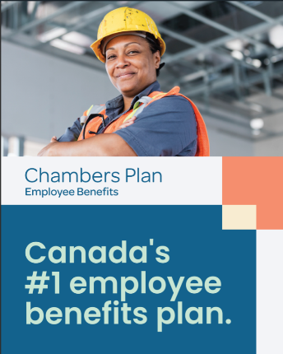 | Finally, employee benefits that work as hard as you do.  Chambers Plan gets you flexible group benefits, like health, dental, disability, critical illness, travel coverage and more, with powerful supports like expert business guidance and mental health resources included at no extra cost.  And its pooled, not-for-profit design helps keep your rates stable, year after year.  Reach out to learn how Canada’s leading plan for small business can help you!  #BenefitTogether #ChambersPlan #SmallBusiness | Download image
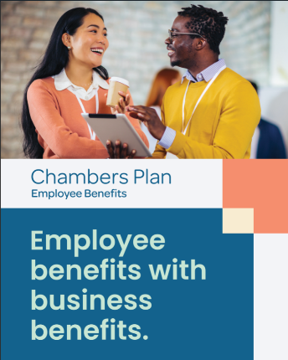 | Canada’s leading employee benefits plan is stacked with supports for business owners.  One-on-one HR, legal and financial guidance; digital guides and templates; and personalized coaching are all included in Chambers Plan, at no extra cost.  Reach out today to learn how Chambers Plan can help you tackle business challenges with confidence!  #BenefitTogether #ChambersPlan #SmallBusiness | Download image
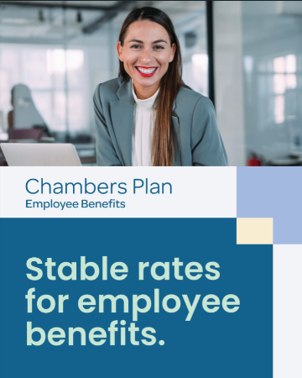 | Get benefits that are built to last.  Chambers Plan helps keep your rates stable, year after year, by bringing together 32,000 Canadian businesses in a pooled, not-for-profit benefits plan.  Reach out today to learn more!  #BenefitTogether #ChambersPlan #SmallBusinessC | Download image
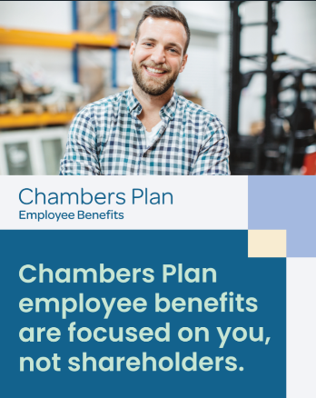 | Does your employee benefits plan put you first? Chambers Plan is not-for-profit, and that’s great for your business.  It’s designed to keep rates stable and offer long-term value, with coverage and service focused on making you - and your employees - feel taken care of.  Reach out today to learn more about Chambers Plan!  #BenefitTogether #ChambersPlan #SmallBusiness | Download image

Video Posts
These videos are optimally sized for Facebook, Instagram and LinkedIn.
Preview Image | Post caption | File Download
 | For small business owners, there’s strength in numbers.  Chambers Plan brings together 32,000 businesses across Canada in a pooled, not-for-profit benefits plan designed to help keep your premiums stable.  You get access to flexible group benefits, like health, dental, disability, critical illness, travel coverage and more.  Reach out today to learn more about Chambers Plan!  #BenefitTogether #ChambersPlan #SmallBusiness | Download video
 | Chambers Plan is proudly not-for-profit, and that’s great for your business.  It’s designed to keep rates stable, year after year, and bring small business owners long-term value like:  - Enterprise-level health, dental, disability, critical illness, travel coverage and more.  - Mental health, wellness, and business guidance tools at no extra cost.  Reach out today to learn more about Chambers Plan!  #BenefitTogether #ChambersPlan #SmallBusiness | Download video
 | Get group benefits that work as hard as you. Chambers Plan includes tools for small and mid-size businesses at no extra cost.  With Chambers Plan, you get access to:  - One-on-one HR, legal and financial guidance.  - Personalized leadership coaching.  - A digital business library full of guides, templates, and other resources.  Reach out today to learn more about Chambers Plan!  #BenefitTogether #ChambersPlan #SmallBusiness | Download video

Story posts
Post these images and videos on your Facebook or Instagram Story. Posts with multiple images can be used in sequence.
Preview Image |  | File Download
 |  | Download image 1  Download image 2
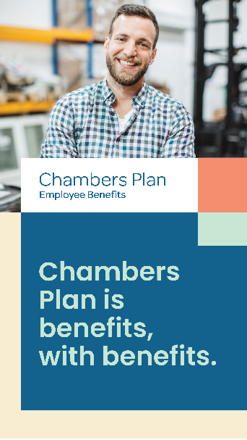 |  | Download image 1  Download image 2
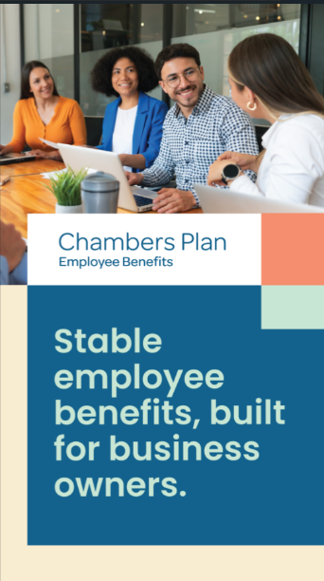 |  | Download image 1  Download image 2

