Chambers Plan Social Content – December 2025
Theme – End of calendar year, winter holidays, planning retirement

POST DATE | ENGLISH CAPTION | ENGLISH IMAGE PREVIEW
2025-12-02 | Employee benefits are the gift that keeps on giving. Offering coverage not only helps you and your team stay healthy — it helps reduce stress, boost productivity, and keep great people on your team longer.  Not sure where to start? Talk to your local Chambers Plan advisor to find the right fit for your business.  #ChambersPlan #ChamberPlan #SmallBusiness #CdnBusiness | 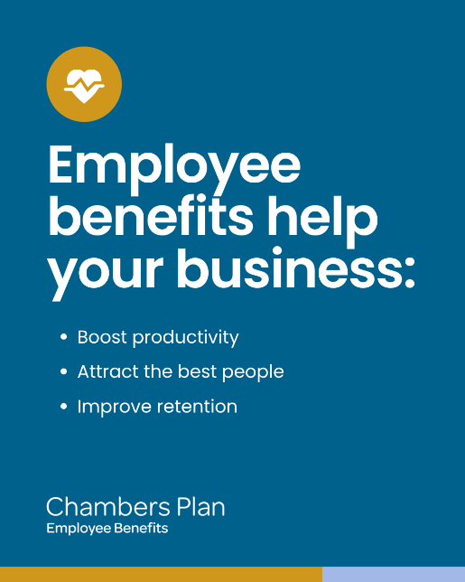
2025-12-04 | Business owners who are getting ready to retire should check out our Retiree Plan. Owners and principals can continue receiving leading Health, Dental and Travel coverage even past the age of 50. Ask us for details.  https://www.chamberplan.ca/members/plan-members/retiree /?utm_source=organicsocial&utm_medium=social  #RetireeBenefits #Benefits #DentalBenefits #CdnBusiness #SmallBusiness | 
2025-12-09 | You may not know what struggles your team is going through — but with an Employee Assistance Program (EAP), you know you can help. Our EAP provider, Arcora, takes the time to understand your employee’s situation and deliver personalized, confidential counselling on mental health, relationships, personal finances and more.  Ask your Chambers Plan advisor how an EAP can effectively support your employees.  #wellness #MentalHealthMatters #ChambersPlan #ChamberPlan #SmallBusiness #CdnBusiness | 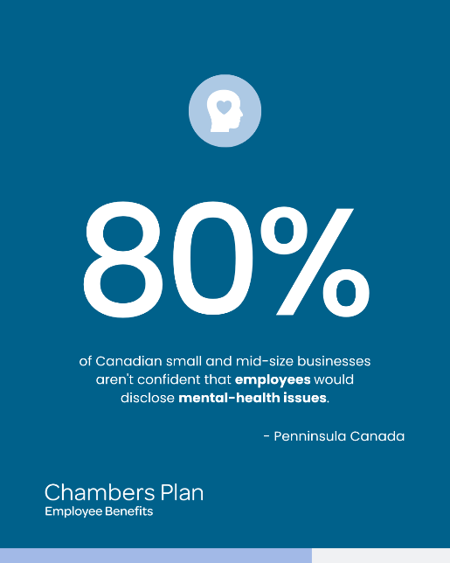
2025-12-11 | Talk to you local Chambers Plan advisor to learn more!  #ChambersPlan #ChamberPlan #SmallBusiness #EmployeeBenefits | 
2025-12-16 | Teladoc telemedicine let’s you talk to a doctor within the hour to receive a diagnosis and even a prescription, all from your home. It’s included with your Chambers Plan Health benefits.  https://www.chamberplan.ca/product/group-benefits/group-health/?utm_source=organicsocial&utm_medium=social  #ChambersPlan #ChamberPlan #CdnBusiness #SmallBusiness #EmployeeBenefits #VirtualCare #VirtualMedicine | 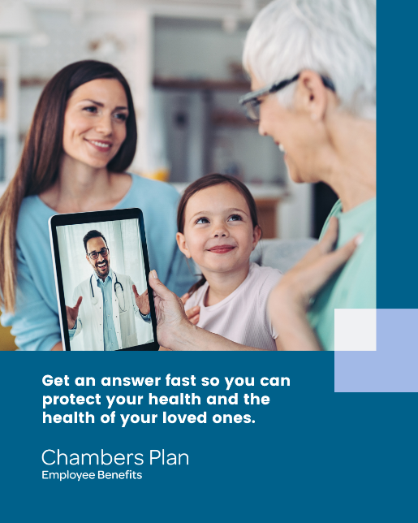
2025-12-18 | Too sore to keep up with the grandkids? Our Health plans include massage therapy, kinesiology, physiotherapy, and more to get you feeling like yourself again. Explore your coverage here:  https://www.chamberplan.ca/product/group-benefits/group-health/?utm_source=organicsocial&utm_medium=social  #ChambersPlan #ChamberPlan #SmallBusiness #wellness #healthyliving #EmployeeBenefits | 
2025-12-30 | Together with your local Chambers Plan advisor and chambers of commerce, we’re proud to help Canadians like you grow your business and protect what matters most.  #ChambersPlan #ChamberPlan #SmallBusiness #CdnBusiness | 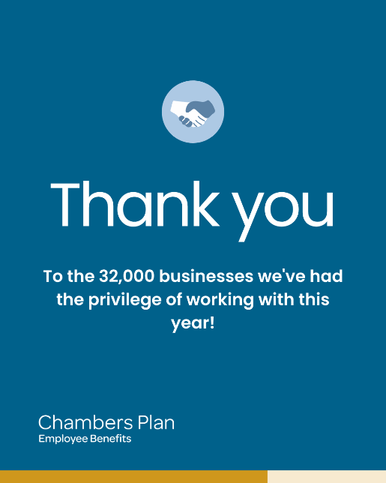
2026-01-01 | Happy New Year! Wishing you a healthy, happy, and successful year. We’re here with you every step of the way!  #ChambersPlan #ChamberPlan #SmallBusiness #CdnBusiness | 

