Chambers Plan Social Content – October 2025
Theme – Small Business Week

POST DATE | ENGLISH CAPTION | ENGLISH IMAGE PREVIEW
10/1/2025 | October is Breast Cancer Awareness Month and this #WellnessWednesday we’re focusing on screening and early detection — important ways to keep yourself healthy.  We encourage our plan members to go to my-benefits health and explore the guide on breast cancer awareness and prevention. It’s free, curated by experts, and can help you find resources and supports in your area. Log into my-benefits to get started.  #BreastCancerAwarenessMonth #HealthyLiving #WellnessWednesday
10/7/2025 | Employee benefits plans can offer more value than a raise or bonus, dollar for dollar. How? After accounting for taxes and deductions like EI and CPP, a benefits plan like Chambers Plan can provide a better return on investment for employers and employees. Ask your local advisor for details.  #ChambersPlan #ChamberPlan #CdnBusiness #SmallBusiness #entrepreneur #growth | 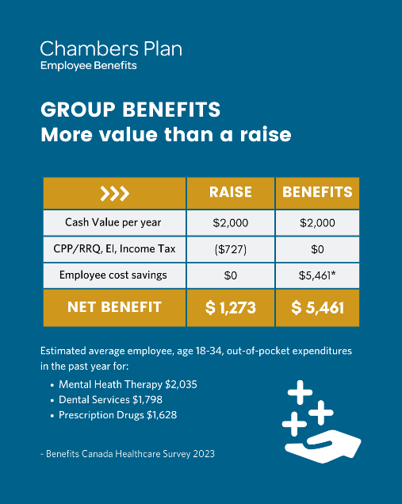
10/10/2025 | World Mental Health Day is a great time to check in on your mental health journey. If you’re feeling like the progress you’re making isn’t where it should be, try Mental Health Navigator, included in our Extended Health plans. It provides an expert second opinion on your treatment plan or diagnosis so you can get back to being your best self.  Learn more: https://www.chamberplan.ca/product/group-benefits/group-health/?utm_source=organicsocial&utm_medium=social  #MentalHealth #EmployeeBenefits #wellness #MentalHealthMatters #ChambersPlan #ChamberPlan
10/10/2025 | Our office will be closed on Monday for Thanksgiving.
10/14/2025 | Chambers Plan gives business owners the peace of mind they deserve. With Chambers Plan, you get stable, predictable rates for flexible coverage like:  - Health  - Dental  - Disability Insurance  - Critical Illness Insurance  - Travel coverage  - And more  Ask your local advisor about Canada’s #1 plan for small and mid-sized business: https://get.chamberplan.ca/?utm_source=organicsocial&utm_medium=social  #ChambersPlan #ChamberPlan #SmallBusiness #CdnBusiness #entrepeneur
10/16/2025 | Did you know that 62% of Canadians businesses have experienced a cyber security incident? Cyber Security Month is a good time to assess and update your knowledge. Start with this guide for small businesses from the Government of Canada:  https://www.getcybersafe.gc.ca/en/resources/get-cyber-safe-guide-small-businesses  #CdnBusiness #SmallBusiness #cybersecurity
10/20/2025 | Happy Small Business Week to the 32,000 organizations that trust Chambers Plan for their benefits. We’re proud to help local restaurant owners, plumbers, hairdressers, farmers, pharmacists, consultants, massage therapists, and more protect themselves and their employees and grow their one-of-a-kind Canadian businesses.  #ChambersPlan #ChamberPlan #SmallBusiness #CdnBusiness
10/23/2025 | Did you know that joining your local chamber of commerce gives you access to professional development, networking opportunities, advocacy, discounts, and exclusive services like Chambers Plan employee benefits? It’s one of the many ways we work together to support Canadian businesses. Talk to your advisor or chamber to learn more.  #ChambersPlan #ChamberPlan #SmallBusiness #CdnBusiness #businessowner #local | 
10/28/2025 | A serious illness or injury can change everything. With Chambers Plan’s Critical Illness coverage, you’ll receive a lump sum to help you manage life after your diagnosis. Funds could be used for installing a wheelchair ramp, paying for your children' schooling, or even covering expenses for your businesses — whatever you need. Talk to your local advisor to learn more.  #ChambersPlan #ChamberPlan #SmallBusiness #CdnBusiness #EmployeeBenefits #businessowner
10/31/2025 | Like full-size candy bars at Halloween, Chambers Plan is giving you more value. That’s why our benefits plans are packed with powerful services for small and mid-size businesses, like professional business guidance and health and mental health supports, at no extra cost.  #ChambersPlan #ChamberPlan #SmallBusiness #CdnBusiness #EmployeeBenefits #businessowner

